JAVA Notes
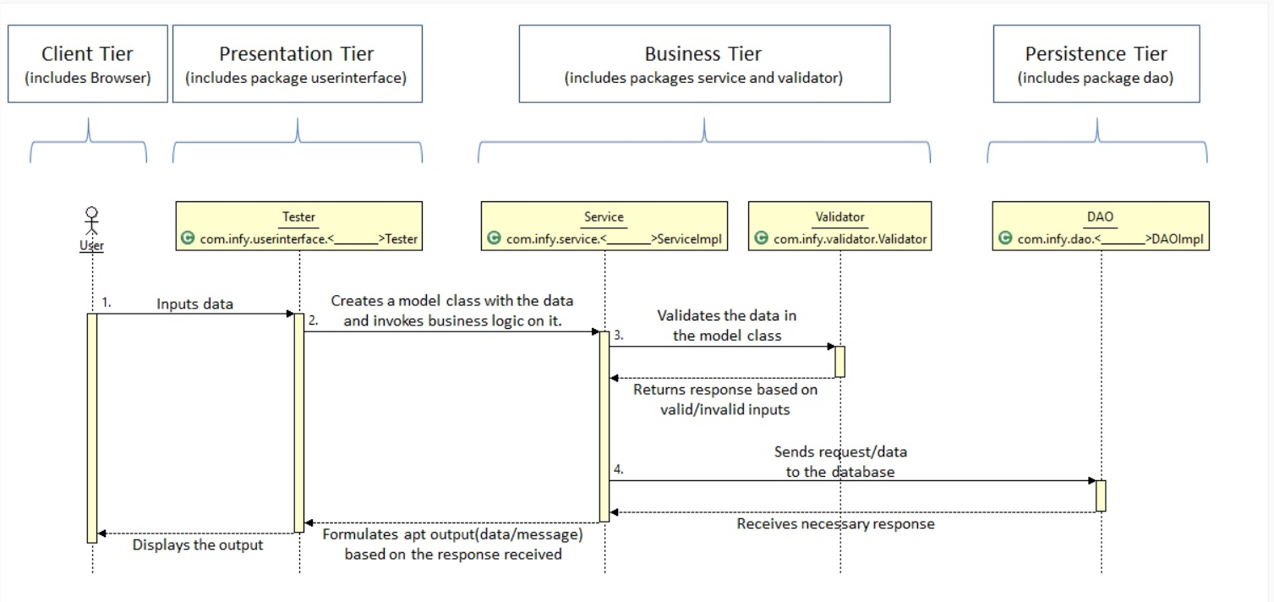
The different steps taking place in the image shown are,
- User inputs the data. This data is sent to the Tester class (or the Presentation Tier).
- The Tester class converts the raw data to a proper Model class object (Objects used to transfer data from one class to another) and send the object to the Service Class (Business Tier).
- The Service class sends the object to the Validator class to get the inputs validated. If the inputs are in valid format, the Validator returns a successful response, else a failure response.
- The Service class performs any business operation to be performed on the data before sending it to the DAO class (Persistence Tier).
- The Persistence Tier interacts with the database and returns the response of the database.
- Based on the responses from the Validator and the DAO classes, the Service class formulates either a successful output or a failure output and return the same to the Tester class.
- The Tester class then displays this output to the User.

Source code: Program written in Java language
Byte code: A .class file is generated after the Java code is compiled. This feature makes Java platform-independent, as the bytecode file can be run on any platform (Windows, Linux, Mac/OS, Sun Solaris etc.)
Class Loader: Loads all the class files needed for execution
Byte code verifier: Checks code for fragments for illegal code
Interpreter: Converts byte code instruction to machine code
Compiler: Compiles reusable byte code instructions to machine code.
Runtime: The overall execution of the program is assisted by Runtime.
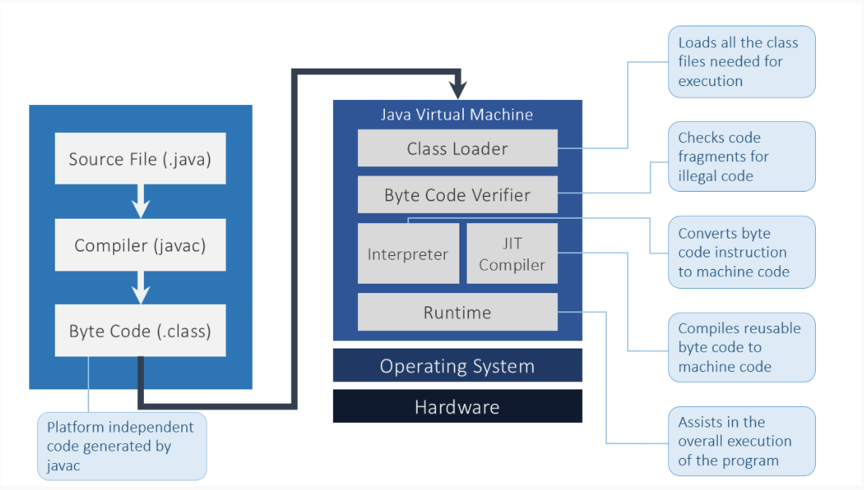

Multi-threaded:
A thread is a separate program that executes concurrently. We can break down a monolithic program handling multiple tasks, into smaller multiple thread-like Java sub-programs that can deal with all the tasks at a given point in time. The main advantage of multi-threading is that threads share a common memory area. Threads are most importantly used for multi-media, web applications, etc.

Some of these words are reserved and have a special meaning in Java, e.g. class, public, void, for, int, static. These words are called keywords. There are 50 keywords in Java 8.
Apart from keywords, there are other words that are used as names to identify components in a program, e.g. sum, index. These words are called Identifiers.
Public static void main (String args[ ])
public: This specifies the level of access of the method within and outside the program. And to make main() method visible to JVM, the level of access must be set to "public". If the same is anything except public (private, protected or default) the JVM will be unable to see the initial/entry point of the program. And hence the program will not run.
static: Generally, a Java program is in the form of a class. And whenever we create classes in Java, we need to create instances/objects to access the class methods and attributes. The same applies to main() method also. But by declaring a class method as "static", we can call that method without creating instances of the class. Hence we declare the main() method as static.
void: In Java, every method is expected to return a value of any type (integer, double, string etc.). And to make a method not return any value, it must be declared "void". Since the main() method is not expected to return any value, it must be declared as void.
main(): As discussed above, a Java program is basically a class. And the main() method is the default method of this class. This method marks the initial/entry point of the Java program.
String args[]: Now a program in general may take inputs from the users. In Java, they are usually in the form of multiple strings as "command line arguments" grouped as an array of string. This string array is taken as the argument in the main() method.
String in Java is immutable. Immutable means which cannot be changed.
StringBuilder Objects are similar to String objects but they can be modified hence they are mutable.
- String name = "Oliver";
- name.concat(" Carter");
- System.out.println(name); //Output Oliver

In the above example, we have string "Oliver" referred by the variable name. Even after using concat, name("Oliver") is not changed, rather a new object is created "Oliver Carter", having no reference. This is because String in Java is immutable. Immutable means which cannot be changed.
To solve this, we will use a mutable class known as StringBuilder. StringBuilder class consists of the append method that concatenates the string with the specified argument which might solve our problem.
StringBuilder is the non-Synchronized version of the StringBuffer class.
- It is used when we do not require thread-safety (thread safety is not covered in this course)
- String and StringBuffer classes are slower than StringBuilder
- It contains all the methods of the StringBuffer class
- ​​​The StringBuilder in Java provides a mutable sequence of characters. The StringBuilder is used as an alternative to the String class in Java because of its mutability
Let us understand the StringBuffer. StringBuffer and StringBuilder classes are preferred for String operations as they are mutable.
- StringBuffer object is mutable i.e. it represents a String that can be changed without creating a new object.
- StringBuffer's capacity can be dynamically increased even though its initial capacity is specified.
- The API's of StringBuffer is synchronized (synchronized keyword is not covered in this course)
- StringBuffer is a final class and it is available in java.lang package
Some of the methods of StringBuffer class are append(), insert(), delete(), reverse().
- String concatenation using the + operator
  - + operator is convenient for simple operation, fixed strings, and for generating a single line output
  - It is inefficient for concatenating large no of strings since Strings are immutable and every time + is invoked a new String object gets created
  - String concatenation using +operator is both time and memory intensive, need to use with care
  - For generating mutable Strings use the StringBuilder class

The enum fields are implicitly static and final, and hence are constant during compile time. But they are instances of their enum type, constructed when the enum type is referenced for the first time.
System.out.* statements are usually used when the developer wants to log some information related to the application on the console. But it is considered bad practice since the information logged by the application and the server the application is running on will log on the same console and it will become highly impossible to separate between the two.
If a developer has a requirement to log information from an enterprise application, it is recommended to use frameworks specifically designed to overcome the issues of the System.out statements like Log4j2, Apache Commons Logging, SLF4J, etc.
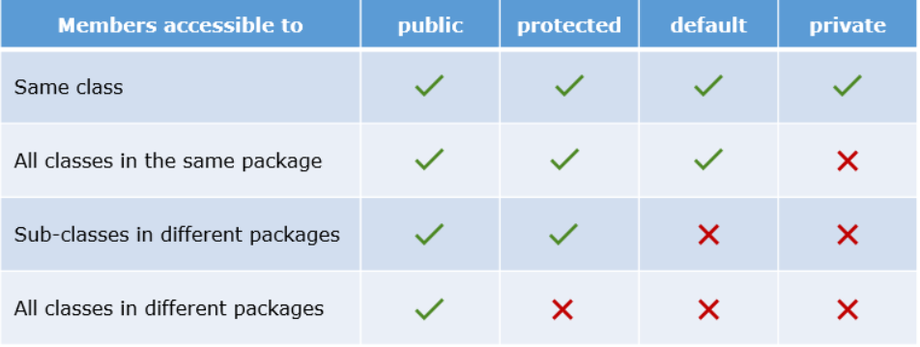
Regex
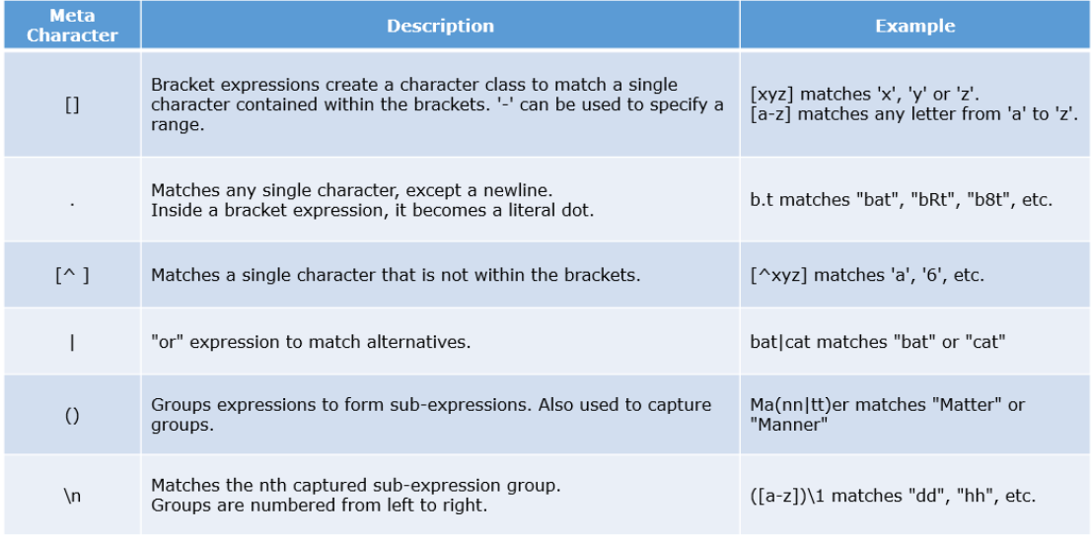
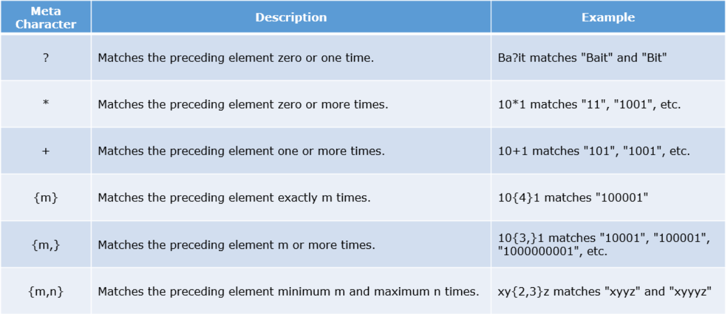
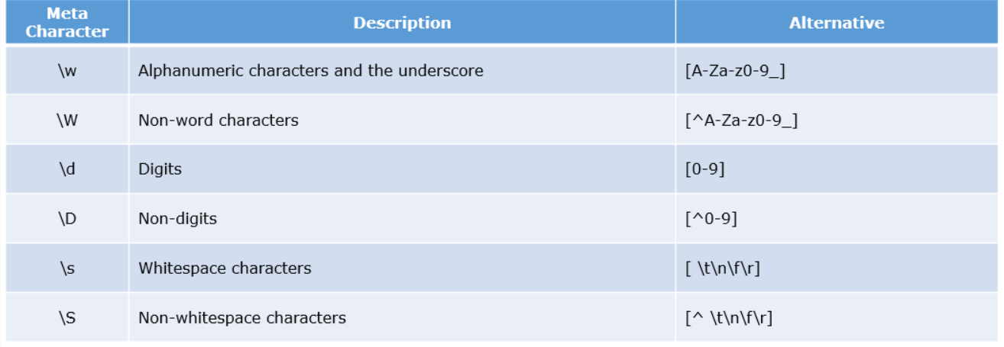
- "\w" is a meta character. But in Java, '\' is an escape character. Hence, we have to escape it using another backslash. E.g. "[\\w]+.
- String passCodeRegex = ".*(\\d)\\1+.*";
- String passCodeStr = "2455254";
- System.out.println(passCodeStr.matches(passCodeRegex));
Here, "\\1" after "(\\d)" in the regular expression is called a backreference.
  - //Regex having three groups being Back-Referenced
  - //The three groups must repeat after the ":" symbol in the String to match the pattern.
  - String repeatRegex = "([A-Za-z0-9]+) (\\d+) ([A-Z]+) [:] \\1 \\2 \\3";
  - String repeatStr = "Tom123 9090 JERRY : Tom123 9090 JERRY";
In the above example, "\\1" refers to the first group "([A-Za-z0-9])", "\\2" refers to "(\\d+)" and "\\3" refers to "([A-Z]+)". And so, the regex expects the string to have all the three groups repeat itself whenever the back referencing is done.

Date Time
Method | Description
LocalDate now() | The current system clock date is returned.
LocalDate plusDays(long daysToAdd) | A LocalDate with the number of days added as specified is returned.
LocalDate plusMonths(long monthsToAdd) | A LocalDate with the number of months added as specified is returned.
LocalDate minusMonths(long monthsToSubtract) | A LocalDate with the number of months subtracted as specified is returned.
LocalDate minusDays(long daysToSubtract) | A LocalDate with the number of days subtracted as specified is returned.
boolean equals(Object obj) | Checks equality of two dates.
int compareTo(ChronoLocalDate other) | Compares the given date to another date.  Returns 0, 1, -1 based on the equality of the specified dates.
int get(TemporalField field) | Fetches the value of the specified field from the given date as an integer.
String format(DateTimeFormatter formatter) | Formats the given date according to the given formatter.
- LocalDate today = LocalDate.now();
- LocalDate newDateObj = today.minusWeeks(39);
- System.out.println(ChronoUnit.DAYS.between(newDateObj,today)); //273
- //between() calculates the amount of time between specified date objects
- System.out.println(ChronoUnit.MONTHS.between(newDateObj,today)); //8
- //compareTo() compares this date with specified date
- System.out.println(newDateObj.compareTo(today)); //-1

- LocalDate dateObj = LocalDate.of(1997, 8, 29);

- DateTimeFormatter df = DateTimeFormatter.ofPattern("dd/MM/yy"); //ofPattern() creates a formatter using the specified pattern.

- System.out.println(df.format(dateObj)); //output 29/08/97

Method | Description
LocalTime now() | The current system clock time is returned.
LocalTime of(int hour, int minute, int second) | According to the values of hours, minutes and seconds a LocalTime is returned.
LocalTime plusHours(long hoursToAdd) | A LocalTime with number of hours added as specified is returned.
LocalTime plusMinutes(long minutesToAdd) | A LocalTime with number of minutes added as specified is returned.
LocalTime minusHours(long hoursToSubtract) | A LocalTime with number of hours subtracted as specified is returned.
LocalTime minusMinutes(long minutesToSubtract) | A LocalTime with number of minutes subtracted as specified is returned.
int get(TemporalField field) | Fetches the value of the specified field from the given time as an integer.
String format(DateTimeFormatter formatter) | Formats the given time using the specified formatter.

- DateTimeFormatter df = DateTimeFormatter.ofPattern("eeee dd/MM/yyyy/ hh:mm:ss a");
- System.out.println(df.format(currentDate));
- //output :- Friday 06/03/2020/ 04:50:54 PM

- DateTimeFormatter dfNew = DateTimeFormatter.ofPattern("eee dd/MM/yyyy/ hh:mm:ss a");
- System.out.println(df.format(currentDate));
- //output :- Fri 06/03/2020/ 04:50:54 PM
As we can see we used modified the pattern with eeee or eee which displays the day of the date.
"eee” – Displays starting three letters of Day of the week such as “Mon”, “Tue”, etc.
“eeee” – Displays the full name of the Day of the week such as “Monday”, “Tuesday” etc.

What is a Static Block?
Java supports a special block, called static block which gets executed when the class is loaded in the JVM. A static block is used for initializing static variables.
The code in the static block will get executed, once either of the below condition satisfies, when
- The object is created
- The first time a static member of that class is accessed.
A Class can have multiple static blocks, which will execute in the same sequence in which they have been written.
Why do we need Static Block?
If a class has static members which require complex initialization, in that case, the static block is the solution.
Rules of Static Block
- Static block cannot return a value.
- Static blocks get executed before constructors.
- Static block is used to initialize static variables only; it gives compilation error if we try to initialize non-static variables.
- Keywords like this and super cannot be used inside the static block.
Code :-
********************************************************************************************
class StudentDetails{
String name;
//static variable
static String department;
static int rollCount=0;
//static block is used to initialize static variable
static{
System.out.println("Inside Static Block");
department="CS";
}
//static method to change the value of static variable
static void change(){
rollCount++;
}
//constructor to initialize the variable
StudentDetails(String studentName){
change();
name = studentName;
}
//method to display values
void display(){
System.out.println(rollCount+" "+name+" "+department);
}
}
***********************************************************************************************
Inheritance
- public RegularCustomer(String custId, String custName) {
- super(custId,custName); //Invoking the parent class parameterized constructor
- this.discount = 5.0f;
- System.out.println("Child Constructor");
- }
Here, super (custId, custName) will send the parameters to the parameterized constructor written in the parent class which will set the attributes for the current object
A base class constructor can be called only in the first line of a constructor.
- Private and Final methods cannot be overridden.
OOPs support the six different types of inheritance as given below:
- Single inheritance
- Multi-level inheritance
- Multiple inheritance -> Interface
- Multipath inheritance
- Hierarchical Inheritance
- Hybrid Inheritance -> Inheritance

Encapsulation
Now have a look at the Customer class below. It has a state variable accountBalance and a behaviour getBalance.
In order to hide the internal state from the outside world, we wrap data and code collectively within a single unit, this process is known as Encapsulation. It mandates that all interactions must be performed through an object's methods.
It means that the variable accountBalance of the Customer class should not be accessed directly by other class entities. It can be accessed only with getBalance() method. Thus we can say that we are hiding the state of Customer class outside this class.
This is possible through access modifiers in Java.
- An abstract class cannot be instantiated using the new keyword.
- The subclass of an abstract class can be only instantiated if it provides the implementation for all the abstract methods.
- If a class has at least one abstract method, then the class must be declared as abstract.
- If the subclass does not implement all the abstract methods, then the subclass must also be declared as abstract.
- An abstract class can also have concrete methods i.e. methods with implementation.
- An abstract class reference can be assigned an object of its subclass, thereby achieving run-time polymorphism.

Java Annotations
- Annotations provide supplement information about the program. It starts with '@' and does not change the flow of the program.
- Annotations are used to associate metadata with the program elements i.e. constructors, methods, etc. It can change the perspective of the compiler for executing the program.
- @Override is a built-in annotation.
- The @Deprecated annotation is a marker annotation and can be used to mark a class, a method or a field as deprecated. It means that it's no longer used.
Rules of Method Overriding
- Final methods cannot be overridden.
- Access level cannot be more restrictive than that of the overridden method.
- Static methods cannot be overridden. (Overloading, Overridden is the mechanism of binding the method call with the method body dynamically based on the parameters passed to the method call. Static methods are bonded at compile time using static binding. Therefore, we cannot override static methods in Java.)
- Private methods cannot be overridden.
- The overriding method must have the same return type and the same number of arguments as in the overridden method.

- public static void main(String[] args) {
- Automobile car = new Car();
- car.start(); // Line 2
- }
Which method will 'line 2' invoke?
A parent class reference can refer to a child class object, i.e. child objects can substitute parent objects (Liskov substitution principle).
The version of the method that will be called is determined by the object, and this decision is taken at runtime. This is called Dynamic binding.
Besides the inherited methods, only the overridden methods can be called using the parent class reference. Any new method created in the child class will not be accessible.
For the proper usage of hash-based structures and algorithms, the hash values of equal objects should be the same. Since we have different methods for equality check and hash code generation, this calls for a contract.
Equal objects must have equal hash codes
In other words, if two objects are equal according to the equals() method, then the hashCode() method on each of the two objects must produce the same integer result.
To maintain this contract both the methods should be overridden in tandem
It is important to understand that if the hash codes of two objects are the same, it doesn't prove that the objects are equal, i.e. it is possible for two unequal objects to have the same hash codes.
hashCode-equals contract:
- If object1 and object2 are equal, their hash code values should be the same.
- If the hash code values of object1 and object2 are the same, it does not prove that the objects are equal.
- If only the equals method is overridden for objects, then their hashCode will be different. This violates the hashCode-equals contract. To maintain this contract both methods equals and hashCode should be overridden appropriately for equality.
Let us understand Wrapper class which resides inside java.lang.package.
Primitive Data Type | Wrapper Type
boolean | Boolean
char | Character
long | Long
float | Float
int | Integer
short | Short
byte | Byte
- Wrapper class is used to represent primitive data types as Objects.
- Java collections cannot store primitive types. It can store only objects.
Always remember that string literals are not eligible for garbage collection throughout the application. On the other hand, String objects can be garbage collected.
In conditional statements, prefer writing "123".equals(stringValue) over stringValue.equals("123") as the latter one can lead to a NullPointerException when stringValue is null
- Applying == on two Strings compares the address of the two Strings.

- String username = new String("Jeena");
- String name = new String("Jeena");

- System.out.println(username== name)

- will print false because both the references point to different addresses.
- Applying the equals method on a String compares the content of the two Strings.

- System.out.println(username.equals(name))

- will print true
- However, in case of String literals, applying == and equals method in the above scenarios will print true.

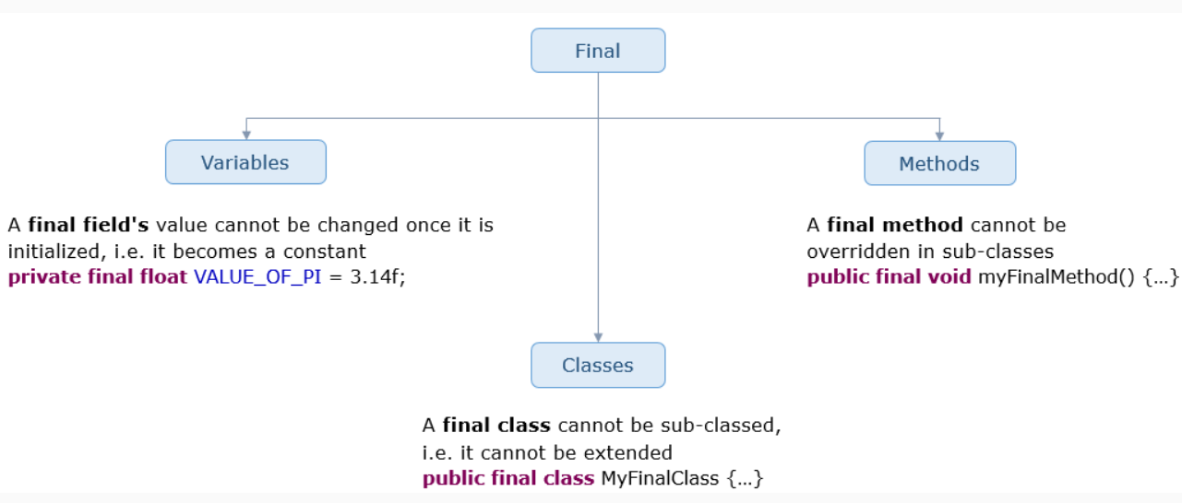

Abstract
The abstract keyword signifies that something is not complete. It can be used with classes and methods.
An abstract class is a class that is incomplete. It cannot be instantiated.
For it to be used, an abstract class has to be made complete by extending it.
- It is generally used when we want to have some behavior but are not sure how exactly it should be implemented.
- An abstract class encapsulates the common behaviors of all its subclasses with the help of abstract methods.
- Concrete (non-abstract) subclasses which extend an abstract class must implement all the abstract methods. Otherwise, they should be made abstract as well.
- abstract class Automobile {
- // Rest of the code
- }
An abstract method is a method without any definition, i.e. the body.
- The signature of an abstract method must be preceded by the abstract keyword.
- If a class contains at least one abstract method, the class should be abstract.
A class can be abstract even without any abstract methods.
- abstract class Automobile {
- public abstract void start(); // Notice the semicolons in the method declarations
- public abstract void stop();
- }
Abstract classes enforce inheritance and Abstract methods enforce overriding
Hence, we achieve dynamic binding.

Interface
Java now allows default and static keywords to declare interface methods.
default is a keyword which when attached to an interface method, allows us to provide an implementation for that method. With this, we can add additional methods in any interface without disturbing the classes which have already implemented the interface. This method can be overridden in the implementing classes if need to be.
static is another keyword introduced which allow us to provide an implementation to the method it is attached to. The difference between static and default is that a method having default keyword can be overridden, whereas, one having static cannot.
- public interface PassengerCar {

- int PRICE_PER_KM = 30;

- default double calculateFare(double distanceTravelled) {
- return PRICE_PER_KM*distanceTravelled;
- }
- static double convertToDollars(double rupees) {
- return rupees/70;
- }
- }
Note: If a class implements multiple interfaces having the same default methods, it has to override them.
From the overridden methods, the default methods of a specified interface can be called using the super keyword.
E.g. PassengerCar.super.calculateFare();
Interface class cannot have constructor.
Interface class and its variables or methods cannot be private, protected.
Interface methods are by default abstract. The methods should not have any body content.
Multiple inheritance possible in Interface but not in abstraction. Means a non-abstract class cannot inherit 2 abstract classes but a non-inheritance class can implement 2 interface classes.

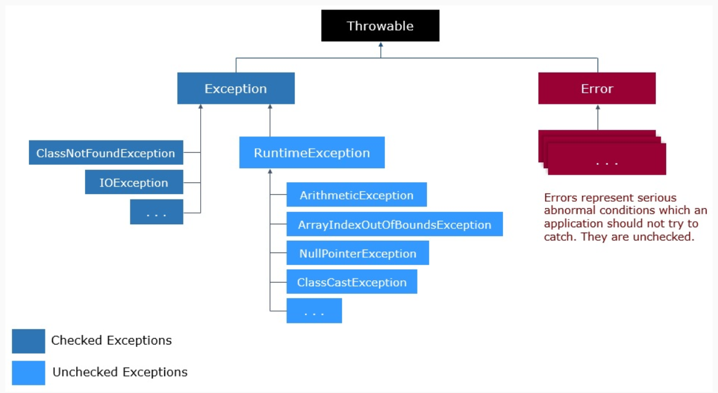
Checked Exceptions:
- If not handled by the programmer, these exceptions will be detected during the compilation of the program which will result in compilation errors.
- Programmers are forced to handle these exceptions or declare its propagation to the calling environment.
Unchecked Exceptions:
- These exceptions are detected during the execution of the program or the runtime, hence causing an error.
- Programmers are neither forced to handle it nor declare its propagation
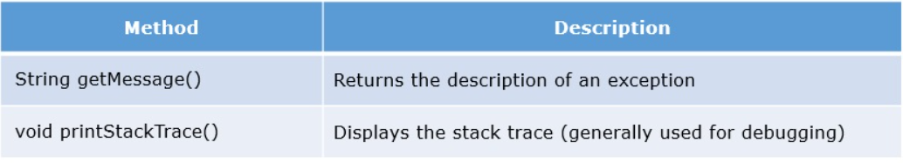
- public class ExceptionDemo {
- public static void divide(int number1, int number2) {
- int quotient = number1/number2;
- System.out.println(quotient);
- }

- public static void main(String args[]) {
- divide(10, 0);
- }
- }
The control starts with the main method. The main method then calls on the divide method. Due to incorrect division operator in the divide method, an exception is created and thrown. This exception terminates any further execution of the program, but internally, the flow is different. In the above case, an exception is generated inside the divide() method. Since the divide() method doesn't take care of it, the exception propagates to its calling environment, which is the main() method. The main() method also doesn't take care of it, and the exception propagates to its calling environment, which is the runtime.
When the runtime environment (JRE) receives the exception, it terminates the program and shows the stack trace.
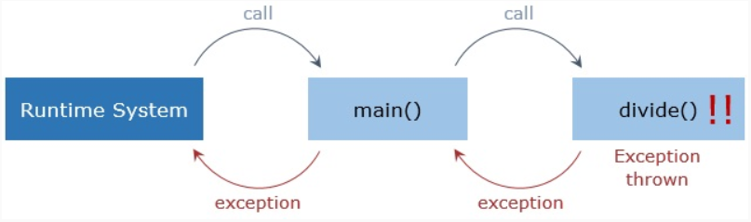
- public static void divide(int number1, int number2) {
- try {
- int quotient = number1/number2;
- System.out.println(quotient);
- }
- catch(ArithmeticException exception) {
- System.out.println("The divisor should not be zero");
- }
- finally {
- System.out.println("At the end of the divide method");
- }
- }
Note: One or more catch blocks or a finally block should succeed a try block.

- public static void checkStock(int stockAvailable, int quantityRequired) {
- try {
- if(stockAvailable < quantityRequired)
- throw new Exception("There is not enough stock available.");
- System.out.println("Please proceed to the check-out");
- }
- catch(Exception e) {
- System.out.println(e.getMessage(), e);
- }
- }

The second ‘e’ inside catch block is for stack trace.
- public class StockNotAvailableException extends Exception {
- public StockNotAvailableException(String message){
- super(message);
- }
- }
- public void checkStock (int stockAvailable, int quantityRequired) throws StockNotAvailableException {
- if(stockAvailable < quantityRequired)
- throw new StockNotAvailableException("The required quantity is not available.");
- }

- Throw specific Exceptions rather than generic ones
- Proper usage of finally block
- Use the catch block only if an exception is supposed to be handled
- Give proper exception message when throwing an exception
- Include the cause of exception when rethrowing an exception
- NullPointerException should never be caught
- Finally block can never have return, break, and continue statement
- It is a good practice not to throw any exception in the finally block
- Finally block should not allow any checked exception to escape, and it needs to be handled

Why the NullPointerException should not be caught?
- Handling NullPointerExceptions reduces the performance of the application, it is always good to do null checks for the inputs
- NullPointerException can be thrown by any expression in the try block, and it is difficult to locate the exact expression which throws the exception
- NullPointerException comes under RunTimeExceptions, which means that the application has a bug that should be fixed immediately. Handling these exceptions without resolving the bug will lead to a violation of efficient coding practices.
Generic Method:
- class GenericMethod {
- public static <E> void displayDetails (E[] inputArray) {
- for (E e : inputArray) {
- System.out.print(e+" ");
- }
- System.out.println();
- }
- }
The displayDetails method shown above takes an array as the parameter, and prints all the elements of the array. Since we have added Generics in this method, it will accept arrays of all the datatypes. The character E used in the method is called a Type Parameter. It replaces itself with the data type of the array that is passed during the execution. For example, if we use an Integer array, then E replaces itself with Integer. We can invoke the function as shown below-
- Integer[] intArray = {1,4,5,2,3};
- GenericMethod.displayDetails(intArray);

- //The output will be: 1 4 5 2 3

- String[] sarr = {"One","Two","Three"}
- GenericMethod.displayDetails(sarr);

- //The output will be: One Two Three

Using iterator()
Let us take a look at code to get iterator object on ArrayList and using its methods to iterate
- List<String> nameList = new ArrayList<String>();
- nameList.add("Harrison");
- nameList.add("Sirius");
- nameList.add("James");

- //iterating using iterator()
- //Getting Iterator object

- Iterator<String> iterator = nameList.iterator();
- while(iterator.hasNext()) {
- System.out.println(iterator.next());
- }
Using listIterator()
Let us take a look at code to get ListIterator object on ArrayList and using its methods to iterate in both forward and reverse direction.
- List<String> nameList = new ArrayList<String>();
- nameList.add("Harrison");
- nameList.add("Sirius");
- nameList.add("James");

- //iterating using listIterator()
- //Getting ListIterator object

- ListIterator<String> literator = nameList.listIterator();

- //iterating in forward direction
- while(literator.hasNext()) {
- System.out.println(literator.next());
- }

- //iterating in reverse direction
- while(literator.hasPrevious()) {
- System.out.println(literator.previous());
- }
remove() method is used to remove elements from a collection while iterating over it. Removing elements in this way can cause errors if collection is getting modified simultaneously by other methods.
When an element is added to an index where already an element is present, then the newly added element take the index and the previous element is shifted to the next position.
HashSet
HashSet is a concrete class which implements Set interface. To store elements HashSet uses hashing mechanism. Hashing involves determining a unique value by using a key. This unique value is called as hashcode. Then this hashcode is used for indexing the data associated with the key.
HashSet can contains only unique elements. When iterated elements in a HashSet are returned in a random order. We can store Null values in a set.
LinkedHashSet
In this type of Set, elements are returned in the order of their insertion.
TreeSet
It uses tree-based data structure for storing elements. Unique elements are arranged in their natural ordering inside the set. It throws a runtime exception if heterogeneous objects are inserted. It depends on the compareTo() method for ordering as well as for detecting duplicates.
Why duplicate objects were not removed from the Set for object?
The answer lies in the implementation of equals() and hashCode() method of Object class. By default equals() method compares object reference to check if two objects are equal or not. Here as two independent objects get added, they are considered to be unequal and hence considered as different by set, so they are not removed.
Since we have overridden equals(), now if we try to print the Set elements once again to check whether the duplicate ‘Moby’ has been removed, we find that duplicate ‘Moby’ object still exists in the Set.
This is because we have overridden only equals() and did not override hashCode(). It is necessary to override both equals() and hashCode() methods due to the general contract defined for these methods on Object class. Also, HashSet class uses the value returned by hashCode() method to determine where and how the object will be stored.
TreeMap
The entries in this map are sorted based on the natural ordering of keys. This class implements SortedMap interface. A SortedMap uses compareTo() method instead of equals() method for key comparison. The TreeMap class exclusively provides few methods such as firstKey(), lastKey(), etc.
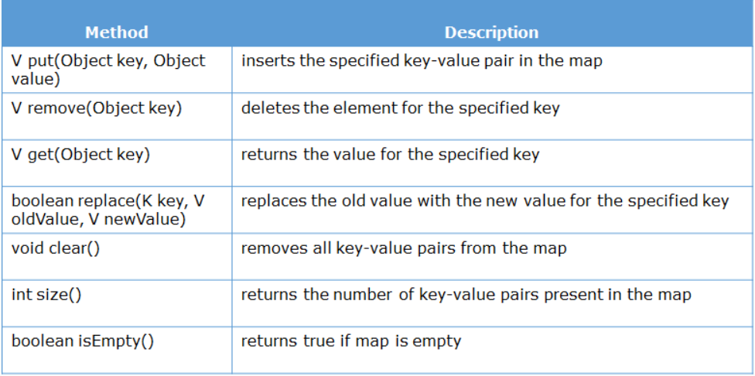
Using entrySet()
Map interface does not have iterator() method defined in it, hence we cannot use iterator() directly on Map. There is a helper interface Map.Entry<K,V> whose objects represent a Map's entry that is a key-value pair. These are available only during the iteration of a Map. There is a method in Map interface entrySet() which returns a set Map.Entry. This set represents all entries (elements) in a Map. We can use iterator() method on this set to iterate over HashMap.
- //Getting set of entries using entrySet()
- Set<Entry<Integer,String>> valueset = books.entrySet();

- //iterating over set
- for(Entry<Integer,String> obj:valueset) {
- System.out.println("Key-"+obj.getKey()+" : Value-"+obj.getValue());
- }
You would have noticed that the Map interface does not extend the Collection interface. Hence, there is no iterator for maps. Also, map values cannot be accessed without keys. So a map cannot be traversed directly.
To overcome this, Map provides us with methods to retrieve a Collection that we can traverse.
There are three different approaches to this:
- Working with the keys:
  - Set setOfKeys = map.keySet();

- Get the Collection of values:
  - Collection valueCollection = map.values();

- Get the set:
  - Set<Entry> setOfEntries = map.entrySet();
The java.util.Map.Entry interface provides two useful methods:
- getKey()
- getValue()
A map to associate students to their courses is shown below:
- Set<Course> courseSet1 = new HashSet<>();
- courseSet1.add(new Course("Java"));
- courseSet1.add(new Course("DBMS"));

- Set<Course> courseSet2 = new HashSet<>();
- courseSet2.add(new Course("PHP"));
- courseSet2.add(new Course("HTML"));
- courseSet2.add(new Course("CSS"));

- Map<Integer, Set<Course>> studentCourses = new HashMap<>();
- studentCourses.put(1001, courseSet1);
- studentCourses.put(1002, courseSet2);

Now, map elements are accessed as:
- //Retrieving the set of Courses by studentID using get() method
- Set<Course> courseSet = studentCourses.get(1001);
- System.out.println(courseSet);

- // Iterating over the set of keys using for-each loop
- Set<Integer> setOfKeys = studentCourses.keySet();
- for(Integer i : setOfKeys) {
- System.out.println(studentCourses.get(i));
- }

- // Iterating over the collection using values() method
- for(Set<Course> courseSet : studentCourses.values()) {
- System.out.println(courseSet);
- }

The team of developers decided to use TreeSet for their requirements. They have implemented the actual logic to persist and process the Product details. Based on the requirement set of products are added to the TreeSet object which is declared as mentioned below.
- //TreeSet class is used as a reference type which is considered to be bad practice
- TreeSet productCollection = new TreeSet();

- //code to add Products to productCollection TressSet
Technically there is nothing wrong with the above logic if the TreeSet is used as a reference type. But assume that after some time the list of requirements changes and the selected TreeSet object is no longer suited to match those new requirements. This means the TreeSet has to be replaced by another suitable Set throughout the application. To make this code to adapt any new changes it is a good practice to always use the Interface types of the collection as a reference type as shown below.
- //Considering interface reference type is a good practice
- Set productCollection = new TreeSet(); //TreeSet object with Set reference type

- //code to add Products to productCollection

To perform an insert or delete operations the developer has to change only the implementation while the rest of the code can remain the same. The developer can use the LinkedHashSet object to store and access the data easier.
Since the reference of productCollection is Set interface, the developer has to change only the object type.
TreeSet
- class Product implements Comparable<Product>{ //Comparable interface has been implemented
- //Instance variables declared as prodId, prodName, category, prodPrice
- //Parameterized constructors are added to assign instance variables
- //Getters and setters

- @Override
- public int compareTo(Product o) {
- return this.prodId.compareTo(o.prodId); //Products will be compared on prodId
- }
- }
Here all the products will be compared by their prodId values and sorted accordingly, to remove any duplicates, the compareTo() method is returning 0 if the prodId of the two objects being compared are equal.
Note: TreeSet uses compareTo() method to sort and remove duplicates.
Hence it is always good practice to override the compareTo() method in user-defined classes whenever class needs to be compared and sorted.
With just hashcode() method overridden and not equals() method, the duplicate values are not removed, also the value fetched for a particular key will be null due to not overriding equals() method

The Comparable Interface is a part of the java.lang package. It has a single method compareTo() which should return a negative, zero or a positive number based on the comparison.
Edford has come up with another similar requirement. They would sometimes need to sort the courses according to the courseId as well.
Since our Course class already implements compareTo() to sort according to the courseName, we'll need an additional component to define another comparison logic.
This can be done with Comparator Interface.
A class can implement the Comparator interface to define a comparison logic in its compare() method. An object of this is passed along with a list to the sort() method.
The Comparator interface is a part of the java.util package. It has a single method compare() that needs to return a negative, zero or a positive number based on the comparison.
- public interface Comparator<T> {
- public int compare(T o1, T o2);
- }

So, we can have a class implementing the Comparator interface like this:
- public class CourseIdComparator implements Comparator<Course> {
- @Override
- public int compare(Course c1, Course c2) {
- return c1.courseId - c2.courseId;
- }
- }

import java.util.ArrayList;
import java.util.Collections;
import java.util.Comparator;

class CourseIdComparator implements Comparator<Course> {
@Override
public int compare(Course c1, Course c2) {
return c1.courseId - c2.courseId;
}
}

class Course {
String courseName;
int courseId;

public Course(int courseId, String courseName) {
super();
this.courseName = courseName;
this.courseId = courseId;
}

@Override
public String toString() {
return courseName;
}

}

class UserInterface {
public static void main(String[] args) {
ArrayList<Course> courseList = new ArrayList<>();
courseList.add(new Course(124, "AngularJS"));
courseList.add(new Course(120, "Java"));
courseList.add(new Course(121, "Hibernate"));

Collections.sort(courseList, new CourseIdComparator());
System.out.println(courseList);
}

}

